CMSC 204
Huffman Lab

- Create a Huffman Tree and generate the codes for each character of the following input:
create a huffman tree
For consistency:
- If same frequency – put in priority queue alphabetically; put space before other characters of the same frequency
- Add subtrees to end of group with same priority
- Lower number has higher priority (goes to front)

c | h | m | n | u | f | r | t | “ ” | a | e
1 | 1 | 1 | 1 | 1 | 2 | 2 | 2 | 3 | 3 | 4

m | n | u | ch | f | r | t | “ ” | a | e
1 | 1 | 1 | 2 | 2 | 2 | 2 | 3 | 3 | 4

U | Ch | Mn | f | r | t | “ ” | a | e
1 | 2 | 2 | 2 | 2 | 2 | 3 | 3 | 4

Mn | F | r | t | “ ” | Uch | A | e
2 | 2 | 2 | 2 | 3 | 3 | 3 | 4

r | t | “ ” | Uch | a | E | mnf
2 | 2 | 3 | 3 | 3 | 4 | 4

“ ” | Uch | A | E | Mnf | Rt
3 | 3 | 3 | 4 | 4 | 4

a | e | mnf | rt | “ ”uch
3 | 4 | 4 | 4 | 6

mnf | rt | “ ” uch | ae
4 | 4 | 6 | 7

“” uch | Ae | Mnfrt
6 | 7 | 8

mnfrt | “” uchae
8 | 13

Mnfrt “” uchae
21

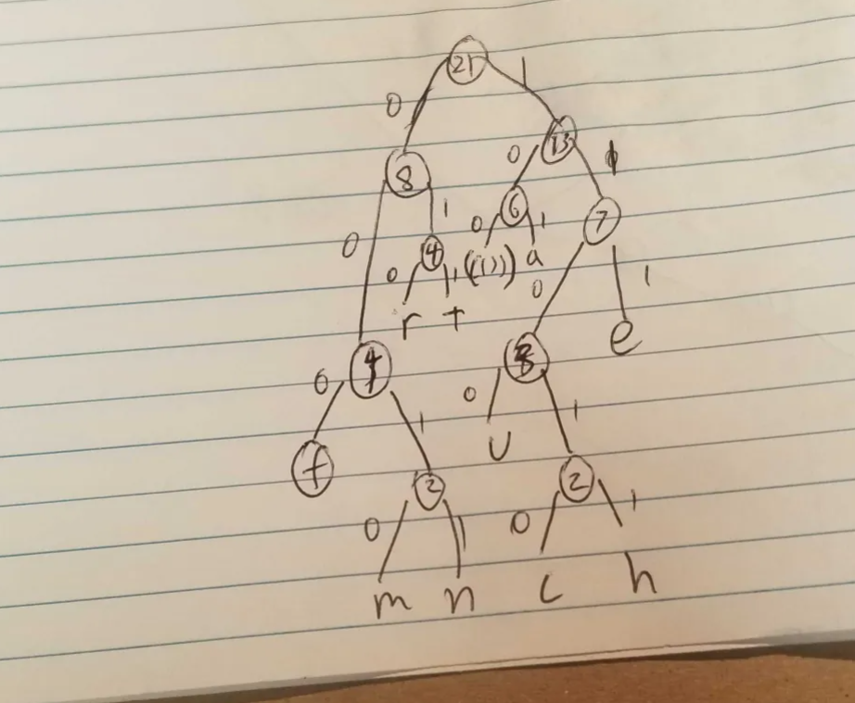

Now encode “create a huffman tree”
C r e a t e “ ” a “ ” h u f f m a n “ ” t r e e
10010 010 111 101 011 111 100 111 100 11011 1100 000 000 0010 101 0011 100 011 010 111 111

- Based on the following Huffman tree and binary sequence, what is the text

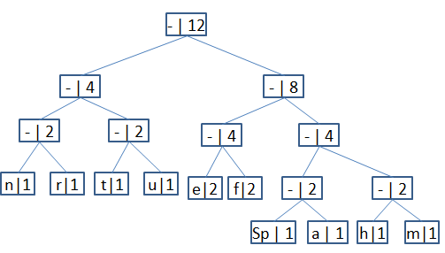

1110 011 101 101 1111 1101 000 1100 010 001 100 100

H u f f m a n “ ” t r e e

